Table of Contents
Table of Contents 1
Overview 3
Common Items 4
Command Buttons 4
Search Button 4
Dialog Boxes 4
Drop-Down Lists 4
Check Boxes 5
Tabs 5
Enabled / Disabled Areas 5
Input 6
Receipts 6
Source Tab 6
History Tab 7
Notes Tab 8
Payments 9
Payment Tab 9
History Tab 10
Notes Tab 10
Command Buttons 10
Payables 11
Payable Tab 11
History Tab 12
Notes Tab 12
Command Buttons 12
Edit / View 13
Entities 13
Entity Tab 13
Supplemental Information Tab 14
Individual Profile Tab 15
Equipment Log 16
Reports 17
User Reports 17
Criteria 18
Board Reports 19
Criteria 19
Other Reports 20
Criteria 21
Tools 22
Database 22
Backup 22
Restore 22
Purge 22
Setup 23
System Settings 23
Letters 24
Lookup Tables 24
Windows 25
Cascade 25
Open Window List 25
Help 26
Contents 26
Search 26
About 26
Databases 27
1. Entites 27
2. EntityInfo 27
3. EntityNotes 27
4. EntityProfile 28
5. EntityTypes 28
6. Equipment 28
7. Expenditures 28
8. ExpenditureType 28
9. FundRaisers 28
10. Letters 29
11. Parties 29
12. Payables 29
13. Receipts 29
14. ReceiptType 29

Overview
A Political Campaign is an intense and involved process. The candidate and campaign staff's time is best spent "campaigning." However, due to regulations and the need for information, keeping accurate records is essential. CampaignSmart provides an easy solution for the accounting, reporting, and tracking needs of political campaigns. This windows-based software provides campaign committees with the ability to track entities (contributors, financial institutions, vendors, others), track transactions (receipts and expenditures), send letters, and produce the reports required by Federal and State governments. Designed with the user in mind, the key feature of this software is its ease of use.

CampaignSmart addresses the areas of a political campaign illustrated below:

Candidate
Committee
Committee
Committee
Transactions
Payables, Payments, Receipts
Reports
Contributors
Financial Institutions
Vendors
Agencies
Other
Fundraisers
Actions & Events
Fundraisers, Letters, Reports
Letters
Entities

Common Items

Command Buttons
- Add
- Edit
- Update
- Cancel
- Clear
- Delete
- Refresh
- Close

Search Button

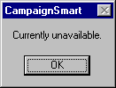Dialog Boxes

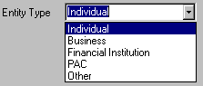

Drop-Down Lists

Check Boxes

Tabs

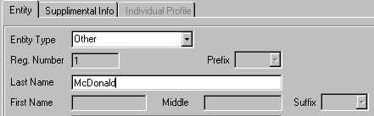Enabled / Disabled Areas

Input

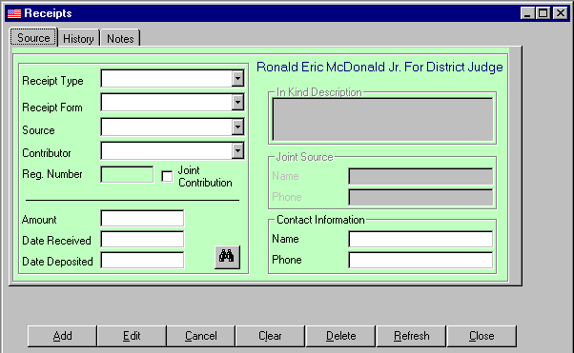Receipts

Source Tab
- Select receipt type
- Select receipt form
- If form is "In Kind", a description must be input.
- Select receipt source
- Select contributor
- The contributor drop-down list is automatically populated with a list of known entities for the selected source.
- Search
- New entity
- Registration number is provided for information only. It is automatically populated and cannot be edited from this screen.
- If contribution is from joint sources, click the Joint Source checkbox.
- Input Joint Source name.
- Input Joint Source phone number.
- Contact information is automatically populated based on the contributing entity.
- Input or edit contact name.
- Input or edit contact phone number.
- Input amount received.
- Input date received.
- Input date deposited

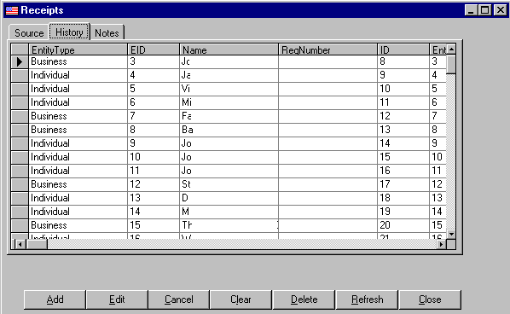

History Tab
- The History Tab is automatically populated with a history of receipts from the contributing entity.
Or
- The History Tab is automatically populated with a history of all receipts.

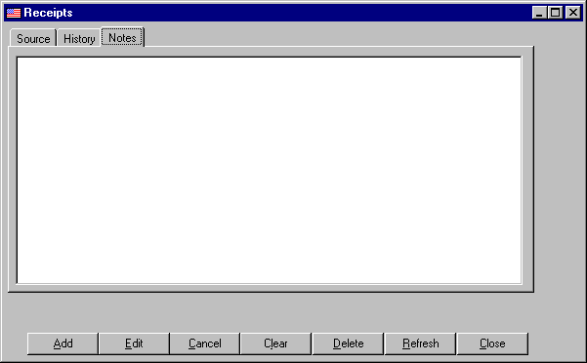Notes Tab
- The Notes Tab is used for recording any notes related to a receipt.

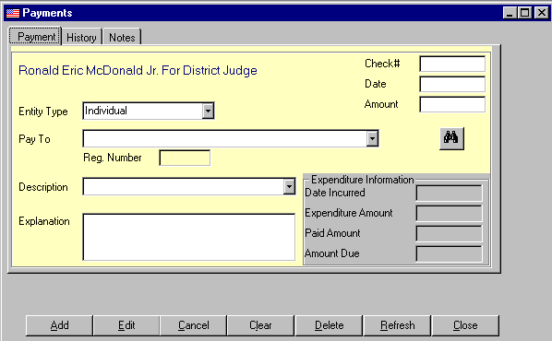Payments

Payment Tab
- Select entity type being paid.
- Select entity being paid.
- The contributor drop-down list is automatically populated with a list of known entities for the selected source.
- Search
- New entity
- Registration number is provided for information only. It is automatically populated and cannot be edited from this screen.
- Input check number
- Input payment date.
- Input payment amount.
- Select description from drop-down list of expenditure types.
- Input explanation.
- Expenditure information is automatically populated for payments of pre-recorded expenditures.
- Date incurred
- Expenditure amount
- Amount paid to date
- Balance due

History Tab
- The History Tab is automatically populated with a history of payments to the selected entity.
Or
- The History Tab is automatically populated with a history of all payments.

Notes Tab
- The Notes Tab is used for recording any notes related to a payment.

Command Buttons
- Add
- Edit
- Update
- Cancel
- Clear
- Delete
- Refresh
- Close

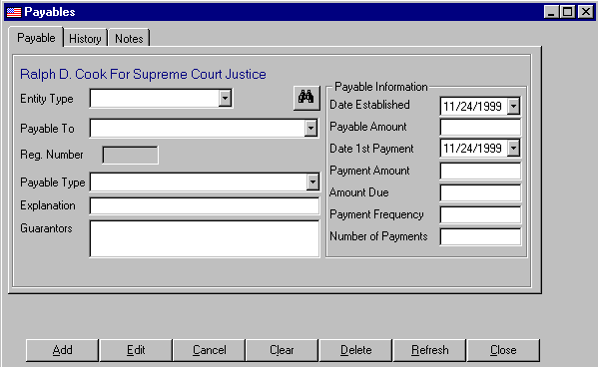Payables

Payable Tab
- Select entity type being to be paid.
- Select entity to payment is to be made.
- The contributor drop-down list is automatically populated with a list of known entities for the selected source.
- Search
- New entity
- Registration number is provided for information only. It is automatically populated and cannot be edited from this screen.
- Select payable type.
- Input explanation.
- Input guarantors.
- Input date payable was established.
- Input payable amount.
- Input date 1st payment is due.
- Input amount of payment.
- Input payment frequency.
- Input number of payments to be made.

History Tab
- The History Tab is automatically populated with a history of payments to the selected entity.
Or
- The History Tab is automatically populated with a history of all payments.

Notes Tab
- The Notes Tab is used for recording any notes related to a payment.

Command Buttons
- Add
- Edit
- Update
- Cancel
- Clear
- Delete
- Refresh
- Close

Edit / View

Entities
- 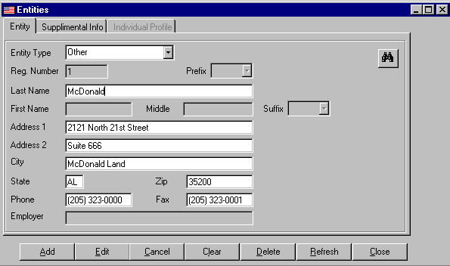New entities are created and existing entities are edited from this form.

Entity Tab
- Select entity type
- Registration number is provided for information only. It is automatically populated and cannot be edited from this screen.
- Search for existing entities for editing.
- Select prefix
- Input last name for individuals or entire name for other entities in the last name field.
- Input first name.
- Input middle name.
- Input address line 1.
- Input address line 2.
- Input city.
- Input state.
- Input zip code.
- Input phone number, including any extension.
- Input fax number.
- Input employer name.

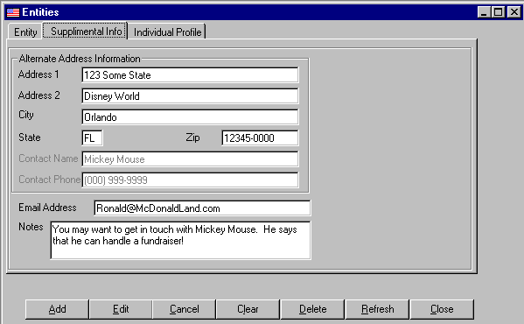Supplemental Information Tab
- Input Alternate Address Information
- Address Line 1
- Address Line 2
- City
- State
- Sip Code
- Contact Name
- Contact Phone
- Email Address
- Notes

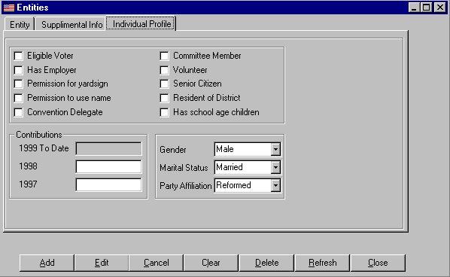Individual Profile Tab
- Profile information provides useful information about individual and allows for grouping individuals.

- Eligible Voter
- Has Employer
- Permission for yard sign
- Permission to use name
- Convention Delegate
- Committee Member
- Volunteer
- Senior Citizen
- Resident of District
- Has school age children
- Current Year Contributions
- Prior Year Contributions
- Second Prior Year Contributions
- Gender
- Marital Status
- Party Affiliation

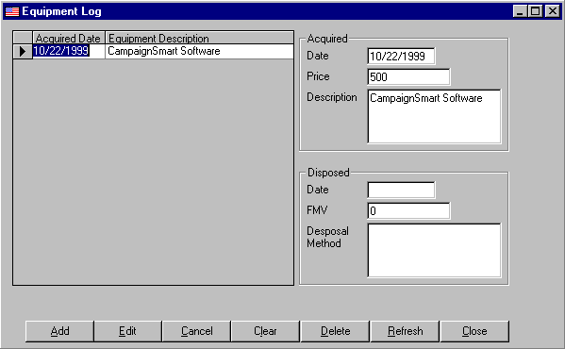Equipment Log

- List of Equipment
- Acquisition Information
- Date
- Price
- Description
- Disposition Information
- Date
- Fair Market Value (FMV)
- Disposal Method

Reports
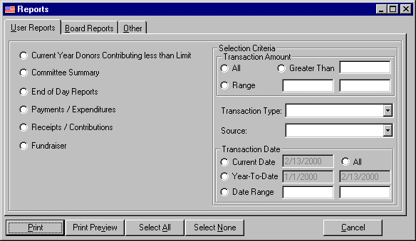

User Reports
 | Report Name | Report File | Report Data | Report Information
X | Current Year Donors Contributing less than Limit  (NEED LIMITS) | LessThan.rpt |  | Sum Receipts By EntityID Into tmpReceipts Where SumAmountReceived > Limit
 | Committee Summary | Summary.rpt |  | Transactions and Events
 | End of Day Reports |  |  | Transactions and Events
X | Payments / Expenditures | ExandDis.rpt |  | Detail vs. Summary
 | Receipts / Contributions | Receipts.rpt |  | Detail vs. Summary
 | Fundraiser | Receipts.rpt |  | ReceiptForm = FundRaiser  (NEED TO CHOOSE WHICH ONE)

Criteria
Transaction Amount
All
Greater Than "AmountReceived > txtAmountGreaterThan "
Range "AmountReceived >= txtAmountLow AND
AmountReceived <= txtAmountHigh "
Transaction Type -
Source "EntityType = comboSource "
Transaction Date
All
Current Date "DateReceived (or DateExpenditure) = Date "
Year-To-Date "DateReceived (or DateExpenditure) >= txtYearStart
AND DateReceived (or DateExpenditure) =< txtYearEnd "
Range "DateReceived (or DateExpenditure) >= txtYearLow
AND DateReceived (or DateExpenditure) =< txtYearHigh "

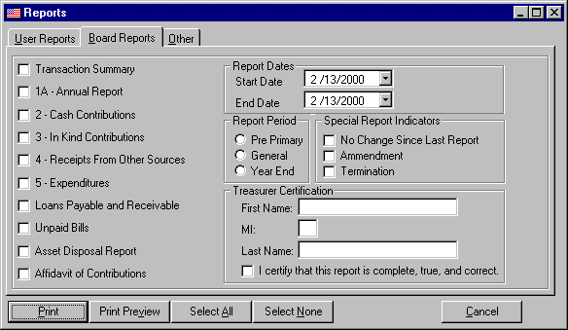
Board Reports
 | Report Name | Report File | Report Data | Report Information
? | Transaction Summary | TransSummary.rpt
X | 1A - Annual Report | Annual_Report.rpt | tmpStats
X | 2 - Cash Contributions | Form2.rpt | tmpReceipts
X | 3 - In Kind Contributions | Form3.rpt | tmpReceipts
X | 4 - Receipts From Other Sources | Form4.rpt | tmpReceipts
X | 5 - Expenditures | Form5.rpt | tmpExpenditures
 | Loans Payable and Receivable | Loans.rpt |  | Payables
 | Unpaid Bills | Unpaid.rpt |  | Payables
X | Asset Disposal Report | AssetLog.rpt | Equipment
X | Affidavit of Contributions | AffofCon.rpt

Criteria
Date Range

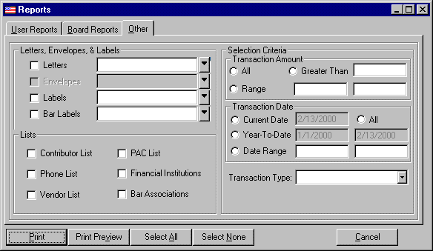
Other Reports
 | Report Name | Report File | Report Data | Report Information
X | Letters | Letters.rpt | Entities  Letters  tmpLetters
? | Envelopes
X | Labels | Label5160.rpt | Entities
X | Bar Association Labels | BarLabel5160.rpt | BarLists
X | Contributor List | EntityList.rpt | Entities  Receipts
X | Phone List | EntityList.rpt | Entities
X | Vendor List | EntityList.rpt | Entities
X | PAC List | EntityList.rpt | Entities
X | Financial Institutions | EntityList.rpt | Entities
X | Bar Association List | BarList.rpt | BarLists

Criteria
(Applies to Letters, Envelopes, & Labels)
Transaction Amount
All
Greater Than "AmountReceived > txtAmountGreaterThan "
Range "AmountReceived >= txtAmountLow AND
AmountReceived <= txtAmountHigh "
Transaction Date
All
Current Date "DateReceived (or DateExpenditure) = Date "
Year-To-Date "DateReceived (or DateExpenditure) >= txtYearStart
AND DateReceived (or DateExpenditure) =< txtYearEnd "
Range "DateReceived (or DateExpenditure) >= txtYearLow
AND DateReceived (or DateExpenditure) =< txtYearHigh "
Transaction Type

Tools

Database
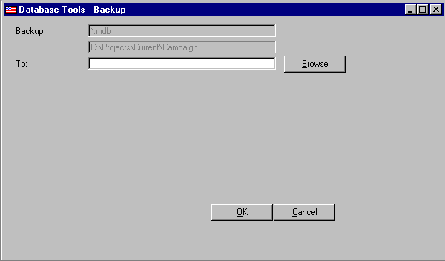

Backup

Restore

Purge

Setup

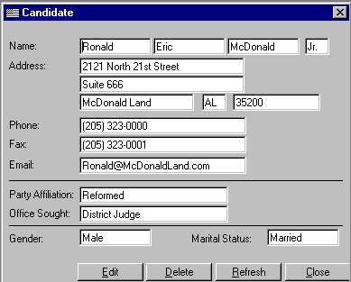System Settings

Candidate
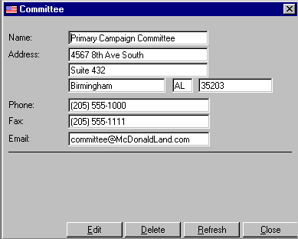
Committee
Compliance Rules

Letters
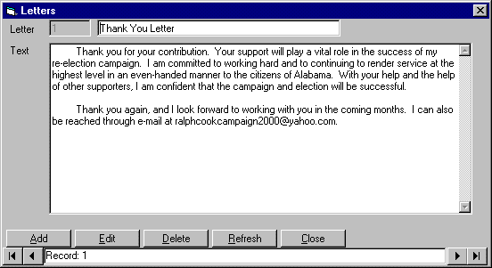

Lookup Tables
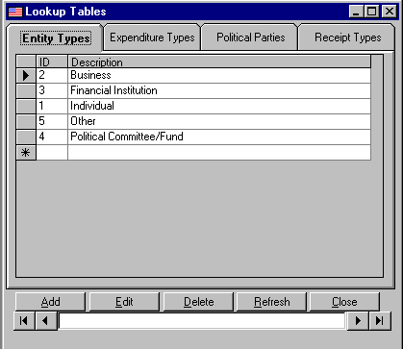Entity Types
Expenditure Types
Political Parties
Receipt Types

Windows

Cascade

Open Window List

Help

Contents

Search

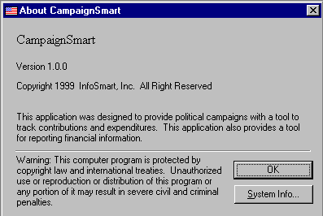About

Databases
Table | Field Name | Data Type | Description
Entites | EntityID  Prefix  FirstName  MiddleName  LastName  Suffix  AddressLine1  AddressLine2  City  State  Zip  Phone  Fax  Email  Source  EntityType  OfficeSought  PartyAffiliation  Gender  MaritalStatus  Employer  RegNumber
EntityInfo | ID  EntityID  AlternateAddress1  AlternateAddress2  ACity  AState  AZip  ContactName  ContactPhone
EntityNotes | ID  EntityID  Notes

Table | Field Name | Data Type | Description
EntityProfile | ID  EntityID  EligibleVoter  HasEmployer  PermissionYardsign  PermissionUseName  ConventionDelegate  CommitteeMember  Volunteer  SeniorCitizen  DistrictResident  SchoolChildren
EntityTypes | ID  Description
Equipment | ID  Description  DateAcquired  Price  DateDisposed  FMV  DisposalMethod
Expenditures | ID  EntityID  Purpose  Explanation  Description  DateExpenditure  AmountExpenditure  Notes  CheckNo  LoanID  FundraiserID  DateIncurred  AmountIncurred
ExpenditureType | ID  Description

FundRaisers

Table | Field Name | Data Type | Description
Letters | LetterID  LetterName  LetterText
Parties | ID  PartyName
Payables | PayableID  EntityID  PayableType  Purpose  Explanation  Description  DateIncurred  Date1stPayment  AmountIncurred  AmountPayment  AmountPayable  Frequency  NumberOfPayments  Guarantors  Notes
Receipts | ID  EntityID  ReceiptType  ReceiptForm  Guarantors  ReceiptSource  DateReceived  AmountReceived  DateDeposited  Notes  InKindDescription  JointSourceName  JointSourcePhone  ContactName  ContactPhone
ReceiptType | ID  Type

